Supply Chain Performance Analysis: A Business Intelligence Case Study using SQL & Excel

Prepared by
Sasi Kumar
Tools Used
- SQL
- Microsoft Excel
- Pivot Tables
- Data Visualization
- Business Analytics
Project Type

- Business Intelligence | Supply Chain Analytics

Executive Summary
This project presents an end-to-end Business Intelligence analysis of a simulated supply chain dataset using SQL for data extraction and business analysis, and Microsoft Excel for interactive dashboard development.
The primary objective was to evaluate supplier performance, inventory health, transportation efficiency, product profitability, and overall operational effectiveness by transforming raw transactional data into meaningful business insights.
The project follows a structured analytics workflow beginning with SQL-based exploratory analysis and KPI generation, followed by Excel-based dashboard development to support executive decision-making. Multiple business metrics including revenue, profitability, inspection pass rates, defect rates, inventory turnover, transportation costs, supplier quality, and product performance were analysed to identify operational strengths, inefficiencies, and opportunities for improvement.
Three interactive dashboards were developed:
- Revenue & Profitability Dashboard
- Inventory Health Dashboard
- Transportation Efficiency Dashboard
The SQL component demonstrates the use of advanced analytical techniques including Common Table Expressions (CTEs), Window Functions, Conditional Aggregation, Business Segmentation using CASE statements, KPI Engineering, and multi-stage analytical pipelines.
The outcome is a business-focused analytical solution capable of supporting strategic decisions in procurement, supplier evaluation, inventory optimisation, and logistics planning.

Business Problem:
Modern supply chains generate large volumes of operational data across procurement, manufacturing, inventory management, logistics, and product distribution. Although organisations continuously collect this information, converting it into meaningful business insights remains a significant challenge.
Management teams often struggle to answer questions such as:
- Which suppliers consistently deliver high-quality products?
- Which product categories generate the highest profitability?
- Are current inventory levels aligned with product demand?
- Which transportation mode provides the best balance between operational cost and product quality?
- Are revenues concentrated among a limited number of suppliers or products?
- Which operational areas require immediate managerial attention?
Without a structured analytical approach, decision-makers risk relying on intuition instead of evidence, potentially leading to increased operational costs, supplier risks, inventory imbalances, and reduced profitability.
This project addresses these challenges by integrating SQL-based business analysis with Excel dashboards to provide actionable insights that support informed decision-making.

Business Objectives
The objectives of this project are to:
- Evaluate supplier performance using revenue, product quality, inspection results, manufacturing costs, and defect rates.
- Analyse product category performance based on revenue generation, profitability, and sales volume.
- Assess inventory health by comparing stock levels with product demand and identifying potential inventory risks.
- Measure transportation efficiency using logistics costs, shipping times, inspection pass rates, and defect rates.
- Identify revenue concentration among suppliers and products to understand business dependency.
- Develop business KPIs that provide a concise view of operational performance.
- Build interactive Excel dashboards to enable executive-level monitoring and business reporting.
- Translate analytical findings into practical business recommendations that improve operational performance.

Dataset Overview
The dataset represents operational information across multiple stages of a supply chain, including procurement, manufacturing, inventory management, product sales, quality inspections, and transportation.
The dataset contains information related to:
- Product Categories
- Individual Stock Keeping Units (SKUs)
- Product Pricing
- Inventory Availability
- Units Sold
- Revenue Generated
- Stock Levels
- Lead Times
- Order Quantities
- Shipping Information
- Transportation Costs
- Manufacturing Costs
- Supplier Details
- Inspection Results
- Defect Rates
The dataset enables analysis across multiple business functions, making it suitable for developing executive dashboards and evaluating supply chain performance from both financial and operational perspectives.

Business Assumptions

Cost Interpretation
The dataset contains multiple cost-related fields, including Shipping Costs, Manufacturing Costs, and Costs.
For profitability analysis, the Costs field was treated as the transportation/logistics cost component where appropriate, while Shipping Costs was retained as a separate operational metric when analysing transportation performance.
Because the dataset documentation does not explicitly define whether the Costs field represents an aggregate or a specific cost component, this interpretation is treated as an analytical assumption rather than a confirmed business definition.

Profit Estimation
Estimated profit was calculated by deducting the identified manufacturing and logistics/transportation costs from generated revenue.
This represents an estimated operational profit, rather than a complete accounting profit, because the dataset does not provide all possible business expenses such as salaries, overheads, taxes, depreciation, or administrative expenses.
Therefore, profitability results should be interpreted as dataset-level estimated profitability.

Inventory Interpretation
Stock_levels was treated as the available inventory quantity associated with the respective SKU records.
Number_of_products_sold was treated as the sales-volume measure used to assess demand relative to inventory.
This allowed the analysis to derive the Sales-to-Stock Ratio as a comparative inventory efficiency indicator.

Sales-to-Stock Ratio
The Sales-to-Stock Ratio was calculated as:
Total Units Sold ÷ Total Stock Levels
The ratio is interpreted as a relative sales-to-inventory indicator, rather than a formal inventory turnover ratio, because the dataset does not provide average inventory over a defined accounting period.
A higher ratio indicates relatively stronger sales volume compared with recorded stock levels, while a lower ratio indicates relatively higher stock compared with sales.

Supplier as Inventory Group
The dataset does not contain an explicit warehouse identifier.
Therefore, supplier-level inventory analysis was used as a proxy for inventory grouping where the business question required a warehouse or location-level comparison.
This assumption should be considered when interpreting the Inventory Health analysis.

Quality Measurement
Supplier quality was assessed using:
- Inspection Pass Rate
- Inspection Fail Rate
- Pending Inspection Rate
- Average Defect Rate
Inspection Pass Rate was calculated as the percentage of records with an inspection result of Pass.
The resulting supplier classifications were created using analytical thresholds defined for this project.

Supplier Quality Segmentation
Suppliers were classified into quality categories using inspection pass-rate thresholds.
Categories such as Excellent, Good, Average, and Poor are analytical classifications created for this project and should not be interpreted as official supplier ratings.

Transportation Efficiency
Transportation modes were evaluated using a combination of:
- Total logistics cost
- Revenue margin
- Average shipping time
- Average defect rate
- Inspection pass rate
- Number of SKUs carried
- Number of routes
- Supplier coverage
No single KPI was treated as sufficient to determine the "best" transportation mode.
Instead, transportation efficiency was evaluated as a multi-dimensional business trade-off between cost, quality, speed, and operational coverage.
This is important because a transportation mode may perform strongly on one metric while performing poorly on another.

Revenue Concentration
Supplier revenue concentration was assessed using the contribution of the top three revenue-generating SKUs.
DENSE_RANK() was used to identify the highest-revenue SKUs within each supplier.
Suppliers were subsequently classified as:
- Highly Concentrated
- Moderately Concentrated
- Diversified
These thresholds are analytical classifications established for the purpose of this project.

General Analytical Assumption
Where the dataset did not provide explicit business definitions for a field, the analysis adopted the most reasonable interpretation based on the available columns and the intended business question.
These assumptions were documented to maintain transparency and ensure that the resulting KPIs and recommendations could be interpreted within the limitations of the dataset.

SQL Methodology & Business Analysis

SQL Methodology
SQL was used as the primary analytical layer to transform the raw supply chain dataset into structured business insights and decision-support metrics.
The analysis was built around specific business questions covering product performance, supplier quality, inventory health, revenue concentration, transportation efficiency, and supplier profitability.
The project demonstrates SQL techniques ranging from basic aggregation to advanced analytical methods, including Common Table Expressions (CTEs), conditional aggregation, joins, window functions, calculated KPIs, and business segmentation using CASE statements.
The resulting SQL outputs were used to support the Excel dashboards and provide the analytical foundation for the project's business recommendations.

SQL Techniques Demonstrated
- SELECT, WHERE, and GROUP BY
- SUM(), AVG(), COUNT(), and COUNT(DISTINCT ...)
- Conditional aggregation
- CASE statements
- Common Table Expressions (CTEs)
- JOIN
- Percentage and KPI calculations
- Window functions
- DENSE_RANK()
- PARTITION BY
- Business segmentation
- Multi-stage analytical queries

Product Category Performance
Business Question: Which product categories generate the strongest sales performance?

SQL Techniques
Aggregation, GROUP BY, COUNT(), SUM(), AVG(), and ROUND()

SQL Query
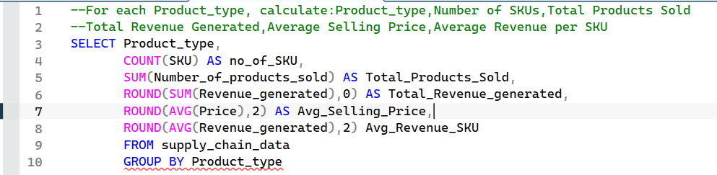

Result
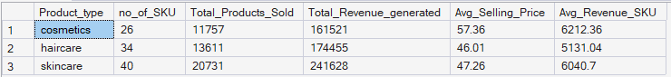

Key Insight
The analysis compares product categories based on SKU count, units sold, revenue, average selling price, and average revenue per SKU.
This provides a broader view of category performance rather than relying on revenue alone. Differences in revenue can be influenced by sales volume, pricing, and the number of SKUs within each category.
The results provide the underlying analysis for evaluating product-category contribution within the broader Revenue & Profitability dashboard.

Supplier Quality & Performance
Business Question: Which suppliers are producing the best-quality products, and how does their quality performance compare with revenue contribution?
SQL Techniques
CTE, conditional aggregation, CASE, COUNT(), SUM(), AVG(), percentage calculations, and GROUP BY
SQL Query
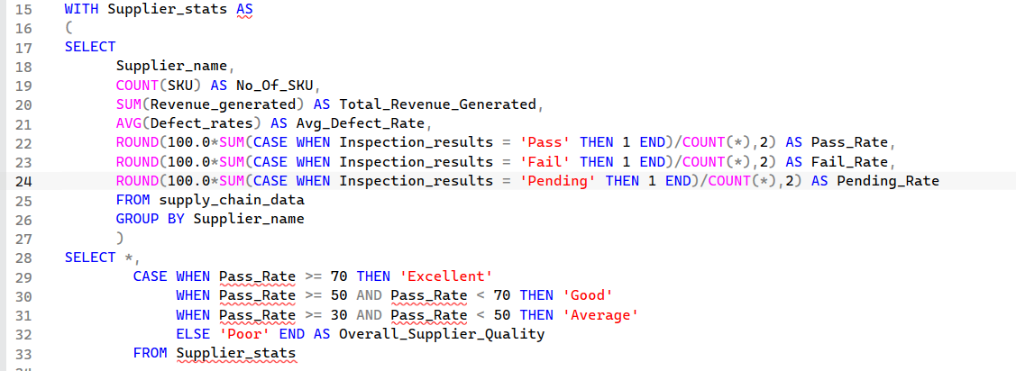

Result
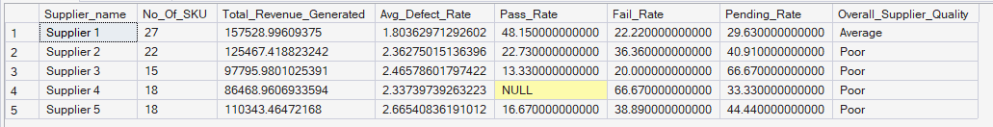

Key Insight
Supplier performance was evaluated using both commercial and quality indicators, including revenue, SKU count, defect rate, and inspection outcomes.
Pass, fail, and pending inspection results were converted into percentage-based KPIs, allowing suppliers to be compared using a consistent quality framework.
The analysis demonstrates that supplier evaluation should consider both financial contribution and operational quality, rather than relying on revenue alone.

Inventory Health
Business Question: Which inventory groups have healthy stock levels and which require management attention?

SQL Techniques
Multiple CTEs, aggregation, conditional aggregation, CASE, JOIN, derived KPIs, and business segmentation

SQL Query
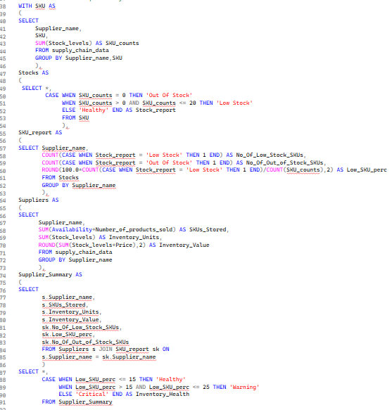

Result
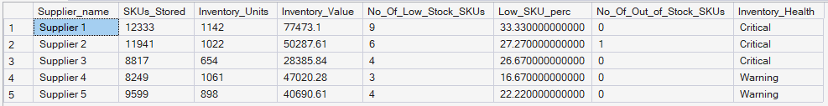

Key Insight
Inventory records were first evaluated at the SKU level and classified into Healthy, Low Stock, or Out of Stock categories.
These classifications were then aggregated to produce supplier-level inventory metrics including inventory units, inventory value, low-stock SKUs, and out-of-stock SKUs.
The resulting health classification provides management with a more meaningful view of inventory risk than total stock levels alone.

Supplier Revenue Concentration
Business Question: Are suppliers dependent on a small number of high-revenue SKUs?

SQL Techniques
CTEs, DENSE_RANK(), window functions, PARTITION BY, aggregation, conditional aggregation, and CASE

SQL Query
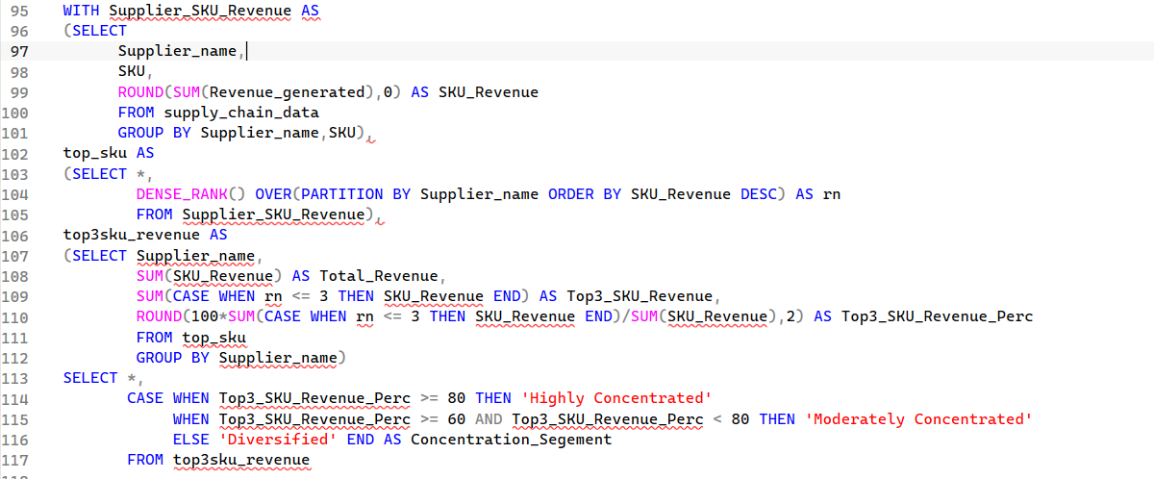

Result
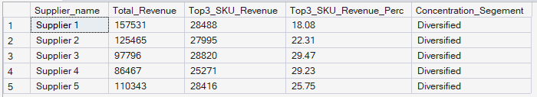

Key Insight
Revenue was aggregated at the supplier-SKU level and ranked within each supplier using a window function.
The analysis then identified the revenue contribution of each supplier's top three SKUs and calculated the percentage of total supplier revenue generated by those products.
This allows suppliers to be classified according to their revenue concentration and helps identify potential dependency on a small number of products.

Transportation Efficiency
Business Question : Which transportation mode provides the best balance between logistics cost, speed, and product quality?

SQL Techniques
Aggregation, COUNT(DISTINCT ...), conditional aggregation, percentage calculations, and multi-KPI analysis

SQL Query
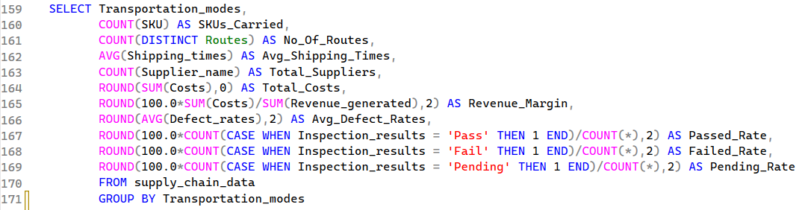

Result

Key Insight
Transportation modes were compared across multiple operational dimensions, including shipping time, logistics cost, revenue margin, defect rate, and inspection outcomes.
No individual metric was used to determine the best transportation mode. Instead, the analysis evaluates transportation as a trade-off between cost, speed, quality, and operational coverage.
The resulting KPIs were subsequently used to support the Transportation Efficiency dashboard in Excel.

Supplier Revenue, Profitability & Quality
Business Question: Which suppliers provide the strongest overall balance of revenue, profitability, quality, and cost?

SQL Techniques
Aggregation, calculated KPIs, conditional aggregation, profit and margin calculations, and multi-dimensional supplier analysis

SQL Query
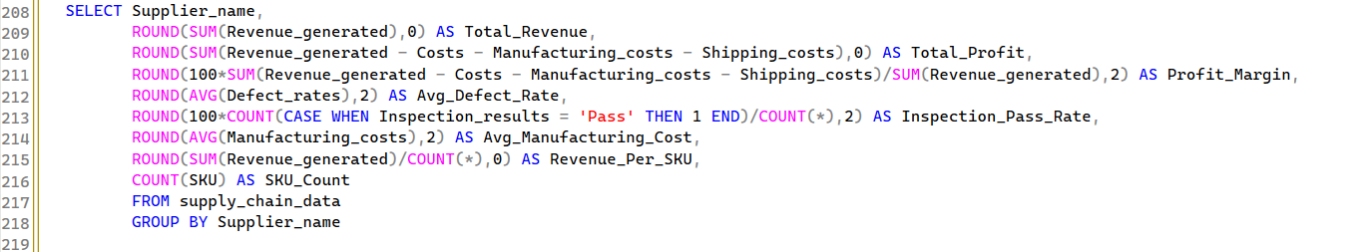

Result
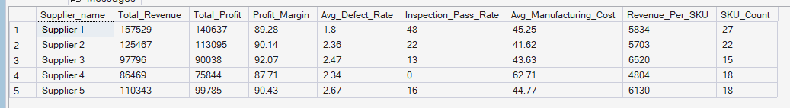
Key Insight
The analysis combines financial, operational, and quality measures into a single supplier-level performance view.
Revenue and estimated profitability provide the financial perspective, while defect rates and inspection pass rates provide an indication of product quality. Manufacturing cost and revenue per SKU provide additional context around supplier efficiency and commercial contribution.
This analysis provides an executive-level perspective of supplier performance and complements the Revenue & Profitability dashboard developed in Excel.

SQL Analysis Summary
The six analyses collectively demonstrate how SQL can be used to move from raw operational data to structured business intelligence.
The analysis progresses from basic category-level aggregation to more advanced techniques such as CTEs, conditional aggregation, joins, and window functions.
More importantly, each query was designed around a specific business question, ensuring that the SQL analysis remained focused on decision-making rather than purely technical data manipulation.

Excel Dashboard Development & Business Insights

Dashboard Development
The SQL analysis was complemented by an interactive Excel dashboard designed to present key supply chain performance indicators in a business-friendly format.
The dashboard was structured into three analytical views:
- Revenue & Profitability
- Inventory Health
- Transportation Efficiency
Excel PivotTables were used as the analytical foundation for the visualisations, while charts and KPI cards were used to convert the underlying analysis into a concise management reporting format.
The dashboards were designed with an emphasis on clarity, comparability, and decision-making, rather than visual complexity.

Revenue & Profitability Dashboard
Dashboard Objective: The Revenue & Profitability dashboard provides an executive-level view of overall commercial performance and highlights the contribution of suppliers and product categories.
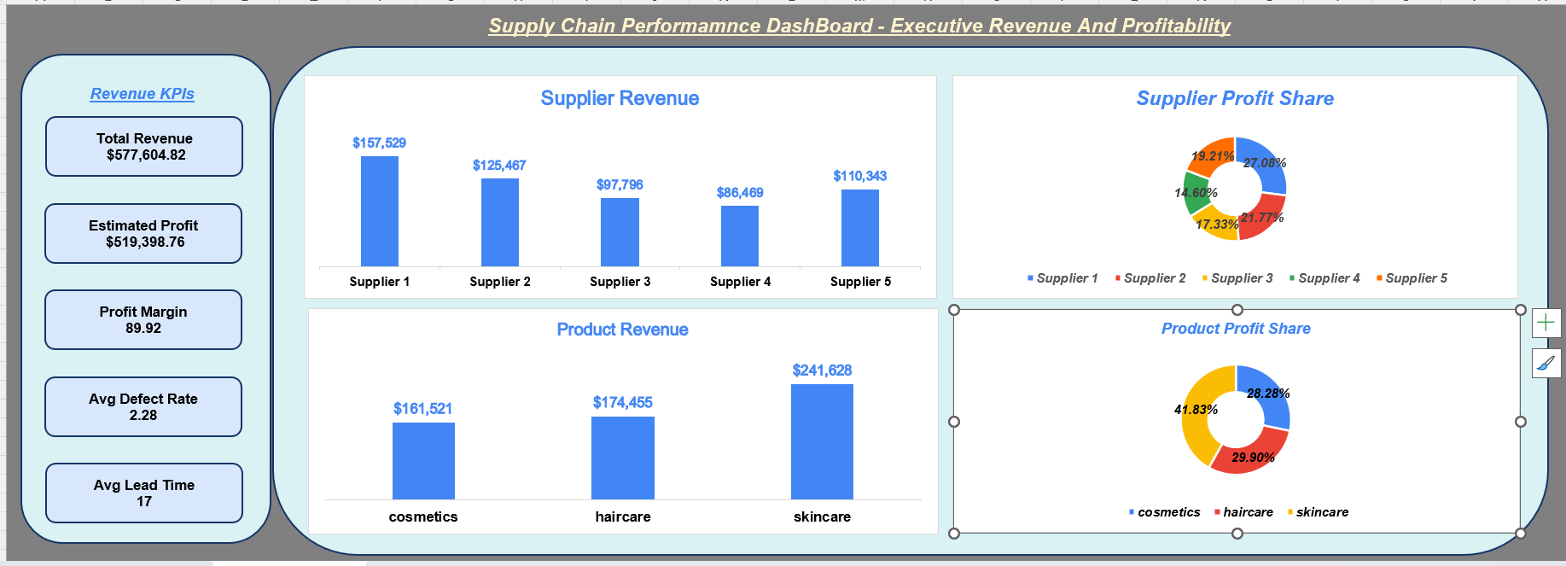

Key Business Insights
The dashboard provides a consolidated view of where revenue and estimated profitability are being generated across the supply chain.
Supplier-level revenue comparison highlights the relative commercial contribution of each supplier, while product-category analysis identifies the categories responsible for the largest share of revenue.
Profit contribution was also analysed by supplier and product category to provide a second perspective beyond revenue alone.
This enables management to distinguish between areas that generate high sales and areas that contribute strongly to estimated profitability.

Inventory Health Dashboard
Dashboard Objective: The Inventory Health dashboard evaluates the relationship between stock levels and sales activity to identify potential inventory efficiency and stock-risk areas.
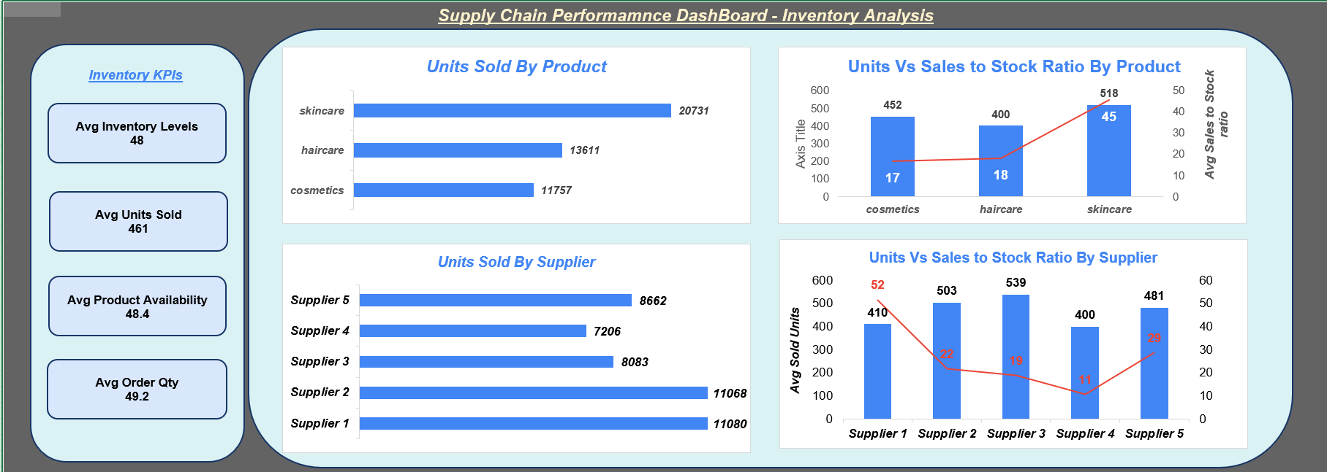

Key Business Insights
The dashboard compares inventory levels against sales activity to identify product categories or supplier groups where inventory may be relatively high compared with demand.
The Sales-to-Stock Ratio provides a comparative indicator of sales volume relative to recorded stock levels. A higher ratio indicates stronger sales relative to available stock, while a lower ratio may indicate comparatively slower stock movement.
The dashboard therefore provides a useful starting point for identifying areas requiring further investigation into replenishment, availability, or potential excess inventory.

Transportation Efficiency Dashboard
Dashboard Objective: The Transportation Efficiency dashboard evaluates logistics performance across transportation modes using cost, speed, quality, and operational coverage indicators.
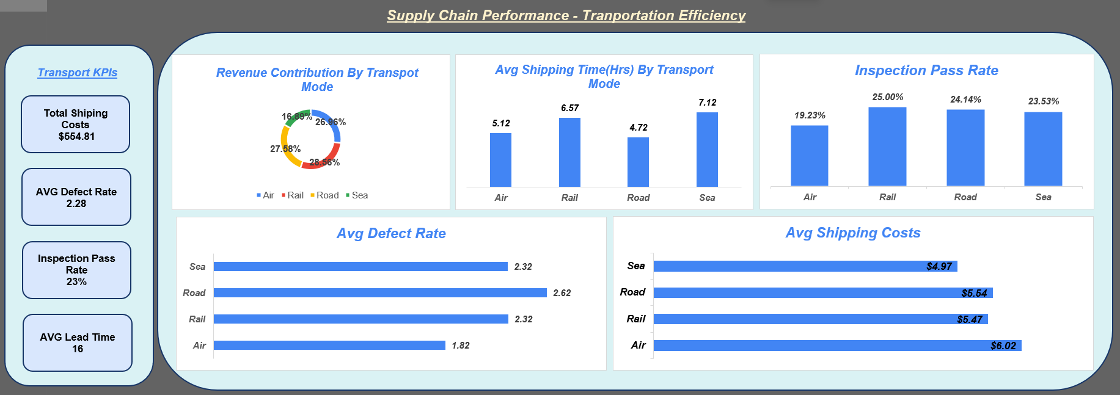

Key Business Insights
Transportation performance was evaluated using multiple dimensions rather than selecting a preferred transportation mode based on a single KPI.
Cost provides a measure of logistics efficiency, while shipping time provides an indication of operational speed. Defect and inspection metrics provide an additional quality perspective.
This multi-dimensional approach allows transportation modes to be compared as a cost, speed, quality, and coverage trade-off, providing a more balanced basis for operational decision-making.

Dashboard Design Approach
The dashboards were intentionally designed using a clean and functional reporting style.
Rather than prioritising decorative elements, the design focuses on:
- Clear KPI presentation
- Consistent visual hierarchy
- Easy comparison across suppliers and product categories
- Appropriate chart selection
- Minimal visual clutter
- Business-focused interpretation
The dashboards demonstrate the transition from raw data and SQL analysis to business intelligence reporting, with Excel serving as the final visualisation and decision-support layer.

Key Findings & Business Recommendations

Key Findings
The combined SQL and Excel analysis identified differences in revenue contribution, supplier quality, inventory efficiency, and transportation performance across the supply chain.
Revenue analysis showed that both suppliers and product categories contributed differently to overall commercial performance, highlighting the importance of evaluating revenue alongside profitability rather than relying on total sales alone.
Supplier analysis demonstrated that financial contribution and operational quality do not necessarily move together. Revenue, defect rate, inspection performance, manufacturing cost, and SKU contribution therefore need to be considered together when evaluating supplier performance.
Inventory analysis highlighted differences between recorded stock levels and sales activity. The Sales-to-Stock Ratio provides a useful comparative indicator for identifying categories that may require further investigation for potential slow-moving or relatively high inventory.
Transportation analysis demonstrated a trade-off between logistics cost, shipping time, and quality. No single transportation KPI should therefore be used in isolation when evaluating transportation efficiency.
The revenue-concentration analysis also provides visibility into suppliers whose revenue may depend heavily on a small number of high-performing SKUs.

Business Recommendations
Use a balanced supplier scorecard combining revenue, profitability, defect rate, inspection performance, cost, and SKU productivity.
Monitor highly concentrated supplier portfolios where a small number of SKUs contribute disproportionately to revenue.
Investigate low Sales-to-Stock Ratio categories for potential inventory-efficiency issues.
Evaluate transportation modes across cost, speed, and quality rather than selecting solely on logistics cost.
Prioritise suppliers with weaker quality indicators for further operational and quality review.

Business Value
The project demonstrates an end-to-end analytics workflow:
Raw Data → SQL Analysis → KPI Development → Excel Dashboards → Business Insights → Recommendations
The combination of SQL and Excel demonstrates the ability to transform operational data into structured analysis and management-oriented reporting.

Limitations & Future Scope

Limitations
The analysis was performed using the fields available in the supplied dataset. Several limitations should therefore be considered when interpreting the results.
The dataset does not provide a complete financial accounting structure. Consequently, the profitability calculations represent estimated profitability based on the cost fields available in the dataset, rather than formal accounting profit.
The dataset also does not provide a clearly defined reporting period or historical time-series information. Therefore, metrics such as Sales-to-Stock Ratio should be interpreted as comparative indicators rather than formal inventory turnover measures.
An explicit warehouse identifier is also not available. Supplier-level grouping was therefore used where inventory analysis required a comparable operational grouping. This assumption should be considered when interpreting the Inventory Health analysis.
The analytical thresholds used for supplier quality, inventory health, revenue concentration, and performance segmentation were created specifically for this project. They represent analytical frameworks rather than official organisational policies or industry standards.
Finally, the dataset is a simulated supply chain dataset and therefore the findings should be treated as an analytical case study rather than direct recommendations for a specific real-world organisation.

Future Scope
The analysis could be extended significantly if additional business data were available.
Potential enhancements include:
- Adding historical sales and inventory data to enable trend analysis and formal inventory turnover calculations.
- Introducing warehouse-level identifiers for more accurate inventory analysis.
- Adding supplier contract and procurement information to improve supplier evaluation.
- Incorporating customer demand forecasts to support predictive inventory planning.
- Adding time-based transportation data to identify seasonal logistics patterns.
- Developing automated data refresh pipelines.
- Migrating the Excel dashboards to Power BI for interactive filtering and enterprise-level reporting.
- Applying machine learning models for demand forecasting, inventory optimisation, and supplier risk prediction.
These enhancements would allow the project to progress from descriptive and diagnostic analytics toward predictive and prescriptive supply chain analytics.

Conclusion
This project demonstrates an end-to-end approach to supply chain business intelligence using SQL and Excel.
SQL was used to transform raw operational data into business-focused KPIs and analyses covering product performance, supplier quality, inventory health, revenue concentration, transportation efficiency, and supplier profitability.
Excel was then used to convert these analytical outputs into three management-oriented dashboards covering Revenue & Profitability, Inventory Health, and Transportation Efficiency.
The project demonstrates that effective data analytics is not limited to writing queries or creating visualisations. The core objective is to translate business questions into measurable KPIs, identify meaningful patterns, and communicate the resulting insights in a way that supports decision-making.
The final workflow demonstrates the complete analytical cycle:
Raw Data → SQL Analysis → KPI Development → Excel Visualisation → Business Insights → Recommendations
This provides a practical example of how SQL and Excel can be combined to support data-driven decision-making across supply chain operations.

